**Good Vision Seva Trust**

**Annual Report**

**(2023-24)**

**Table of Contents:**

1. **Message from the Founder/CEO**
2. **Vision, Mission, Objectives and Nature of the Organization**
3. **Key Highlights of the Year**
4. **Program Overview with Impact Assessment**
5. **Education**
6. **Livelihood Support**
7. **Disaster Management**
8. **Women Empowerment**
9. **Health Care**
10. **Environment**
11. **Financial Overview**
12. **Acknowledgements**
13. **Future Plans**
14. **Contact Information**

**(1) Message from the Founder:**

Good Vision Seva Trust marks yet another year of progress in its mission to build a self-sustained society. As a social organization, it remains committed to the sustainable development of marginalized communities, embracing individuals from all backgrounds irrespective of any differences. The organization operates under the visionary leadership of its founder, Mr. Mano Thangaraj, a well-known social activist whose dedication to community empowerment has been instrumental in shaping the organization’s initiatives. Founded in the year 2000 in Kanyakumari district, GVST continues to focus on the development and upliftment of the less privileged, and pursuing with dedication and perseverance to create lasting change in the community and empower those in need.

GVST firmly believes that true self-sustainability for vulnerable communities can only be achieved by empowering them both socially and economically. Guided by this vision, the organization is committed to fostering resilience through collaborative efforts. It integrates community participation at every stage of the social development process, ensuring that the people it serves are not just beneficiaries but active partners in shaping their own future. With a focus on innovation, the organization continuously introduces developmental programs tailored to address the unique needs and also challenges faced by these communities, paving the way for long-term progress and empowerment.

We have taken purposeful strides towards empowering the poor and the dispossessed amongst us. We have carried out the following activities in Kanyakumari district with prime focus on less privileged people, women and the community for their socio-economic uplift and environmental sustainability. We have provided employment opportunities, homes for the homeless, education support, sanitation and various skills to help the marginalized to come up in life. Much more work is yet to be done in the upcoming years in our prime focus areas across Tamil Nadu. Among others, we aspire to scale up our new initiative “English for Economy” program to other districts such as Chennai, Coimbatore, Ooty, and so on. Besides, we also plan to execute skilling programs for the youth/students and women across the state with the support of new partners in the domain.

**(2) Vision:** Towards building a self-sustained society.

**Mission:**

To enable the marginalized, the neglected and vulnerable to lead an enriched and complete life.

**Objectives:**

* Promotion and facilitation of Self Help Groups for self-sustenance.
* Mobilising the marginalised people especially the unemployed, unorganised labourers and rehabilitation of devastated people by natural and man-made disasters, etc.
* Providing Entrepreneur Development Programs (EDP) and Skill Trainings.
* Rejuvenation and conservation of natural resources and protection of environment.
* Addressing health issues and promoting alternate and indigenous health care practices, and awareness of health care.

**Nature of the Organization:**

Good Vision Seva Trust (GVST) is a secular, non-political, and non-profit organization dedicated to promoting the sustainable development of marginalized communities, transcending barriers of gender, linguistic, ethnic, caste, and creed. Our mission is to empower economically less privileged individuals and groups by providing them with access to resources, opportunities, and support systems that enable them to improve their socio-economic status and contribute positively to their communities.

GVST recognizes that every individual has inherent value and deserves equal opportunities to realize their full potential. We are committed to working towards a society where all people have access to basic necessities such as education, healthcare, clean water, sanitation, and employment opportunities. Our approach is holistic, considering all the factors that impact the lives of our target communities.

Through our programs and initiatives, we aim to foster a culture of inclusivity, equality, and social justice. We work closely with local communities, government agencies, and other stakeholders to identify areas of need and develop targeted interventions that address these needs. Our goal is to create lasting impact, empowering marginalized communities to become agents of change in their own lives and in their communities.

At GVST, we believe that everyone deserves the opportunity to live a life of dignity and respect. We are committed to working tirelessly towards this vision, guided by our core values of compassion, empathy, and social responsibility.

**(3) Key Highlights of the Year:**

* Successfully facilitated A&R (Animator & Representative) training for 930 women from various Self Help Groups (SHGs).
* Similarly, facilitated for Entrepreneurship Development Program (EDP) and SHG training given by PLF for 5,580 women representing different SHGs, equipping them with the tools and knowledge to improve their employability and build sustainable livelihoods.
* Facilitated credit linkage for 20 Joint Liability Groups (JLGs) and 5 SHGs, benefitting approximately 300 women with a total loan amount of Rs.1,10,00,000/- through NABARD – NABFINS loan facility.
* Launched a pilot project in 13 government schools, reaching nearly 1500 students and equipping them with English communication skills.
* Successfully placed around 25 educated unemployed housewives as volunteer teachers in the English pilot project, providing them with valuable job opportunities.
* Following the success of pilot project, we are expanding the “English for Economic Opportunities” program to additional government schools in Kanyakumari district.
* In 2023, we played a crucial role in the Ockhi Cyclone and other heavy rainfall and Flood rescue/relief operations, providing critical support to those affected by the natural disaster. Our efforts helped numerous individuals and families including children, women, differently abled and elderly people navigate the challenging situation, ensuring their safety and well-being.
* Successfully organized three Eye Camps assisting over 150 patients.
* Conducted a Mega Free Career Guidance program for thousands of +2 students.

**(4) Program Overview with Impact Assessment:**

**A) Education Support and New Initiatives**

Education is the gateway to a brighter future, and rural development is incomplete without addressing the accessibility of quality education for children in these areas. It has a profound impact on living standards by boosting knowledge, skills, and intellect, enabling individuals to lead fulfilling lives. Good Vision Seva Trust is committed to bridging the educational divide by providing vital support to underprivileged students in Kanyakumari District, paving the way for a brighter tomorrow for the next generation.

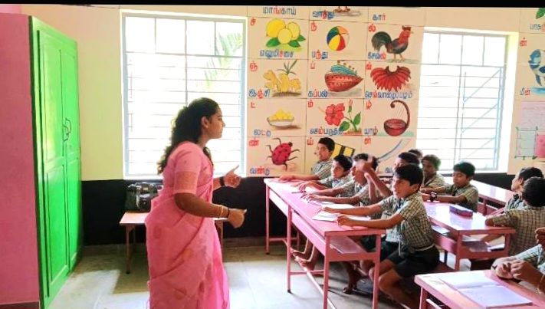

(One of the volunteer teachers engaged in “Vocabulary Drill” in the classroom)

Kanyakumari District, despite being a leader in many development indicators, faces a significant challenge: a lack of English proficiency. Despite a high literacy rate, students have limited exposure to English communication. This is particularly concerning for students from vulnerable socio-economic backgrounds, who have few opportunities to develop their communication skills. Even graduates struggle to find quality employment due to their limited proficiency in English, which exacerbates the issue. The inability to communicate effectively in English can lead to career stagnation, regardless of an individual's subject knowledge. Recognizing this issue, Good Vision Seva Trust (GVST) collaborated with linguistic experts to design an English language program for Government school children. A pilot program was successfully conducted in 13 schools during 2023-2024. Building on this success, GVST has launched the "English for Economic Opportunities" mission, aiming to transform the future of at least 10,000 Government School students in Kanyakumari District by 2024-2025. The project will be implemented in Kanyakumari, Chennai, Coimbatore and across Tamil Nadu.

**(B) Livelihood Support**

Efforts have been made to train women from SHGs in mushroom cultivation as part of livelihood promotion activities. In our initiative to promote sustainable livelihoods, we have implemented a comprehensive training program for women from Self Help Groups (SHGs) focused on mushroom cultivation. The detailed efforts in this activity include:

Conducted assessments to identify the interest levels and existing skills of SHG women regarding mushroom cultivation. Discussed in SHG meetings to raise awareness about the nutritional benefits and market potential of mushrooms, highlighting the advantages of this livelihood option.

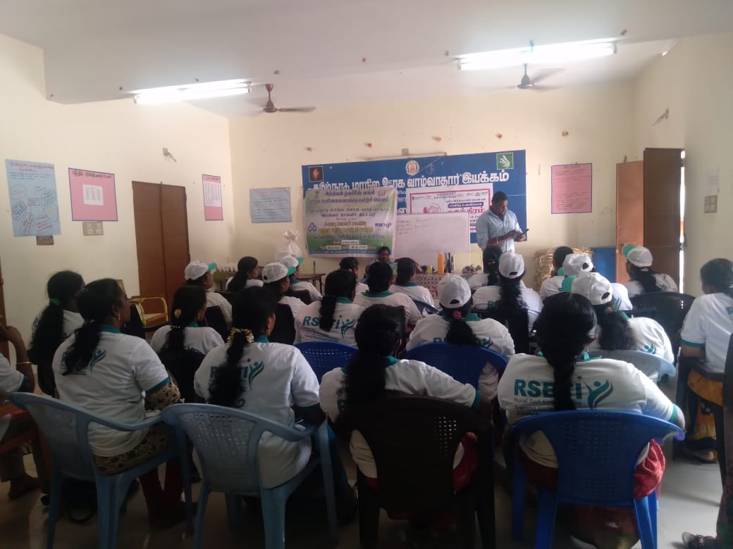 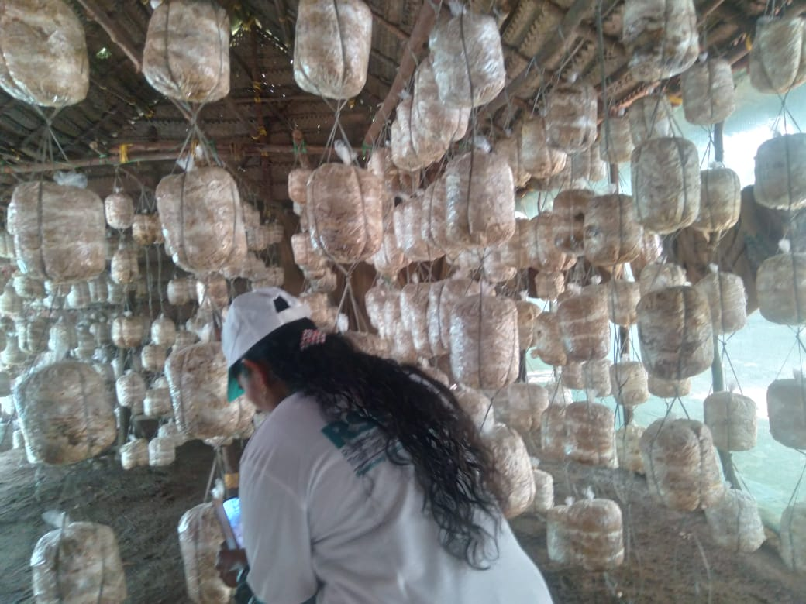

(Mushroom Cultivation Training for SHG women)

Provided practical, hands-on training sessions where participants learn the various techniques of mushroom cultivation, including substrate preparation, inoculation, and harvesting. Supplying necessary materials such as spawns, substrates, and tools to enable SHG women to start their mushroom farming activities. Engaged agricultural experts and experienced mushroom farmers as trainers to ensure high-quality instruction and support throughout the training process. Assisted trained women in establishing market linkages to sell their produce, thereby creating sustainable income sources. Offering continuous support and guidance post-training, including follow-up visits to address challenges and share best practices in mushroom cultivation. Finally, creating opportunities for SHG women to connect with each other and share experiences, fostering a community of practice around mushroom cultivation. Through these concerted efforts, we aim to empower women economically, enhance their skills, and contribute to food security in the community.

**(C) Disaster Management**

In 2023, we made significant contributions to rescue operations in response to the Ockhi Cyclone as well as other heavy rainfall and flooding incidents. Our organization provided essential support to those impacted by these natural disasters, playing a pivotal role in addressing their immediate needs.

Our dedicated team worked tirelessly to assist numerous individuals and families, paying special attention to vulnerable groups such as children, women, persons with disabilities, and the elderly. We implemented a range of initiatives to ensure their safety and well-being during this challenging time.

This included the provision of emergency shelter, food, clean drinking water, and medical assistance to those displaced by the disasters. We also established communication channels to inform affected communities about available resources and support services.

Our volunteers and staff conducted outreach efforts to assess the specific needs of these groups, helping to create tailored support plans that addressed their unique circumstances. Through collaboration with local authorities and other organizations, we strengthened our response efforts and maximized our impact on the ground.

In addition to immediate relief efforts, we began laying the groundwork for long-term recovery by offering counseling services, rebuilding initiatives, and skill development programs to help affected families regain their livelihoods. Overall, our comprehensive approach ensured that those impacted by the Ockhi Cyclone and subsequent floods were not only assisted in the moment but also supported in their journey towards recovery and resilience.

**(D) Empowerment of Women**

Empowerment of women has been one of GVST’s core areas of intervention since its inception, with a strong focus on enabling women through essential knowledge and practical skills. GVST’s initiatives have significantly impacted the lives of women, particularly those from rural and socio-economically disadvantaged backgrounds. These efforts have enabled many women to overcome social challenges and discrimination, and improve their financial independence, and contribute to their communities.

**Key Programs and Activities for Women’s Empowerment**

GVST has implemented a series of programs designed to provide women with the tools and confidence needed for personal and community-based growth. The majority of participants are actively engaged in Self-Help Group (SHG) activities, which serve as a foundation for empowerment. The core programs and activities conducted by GVST include:

1. **Promotion of SHGs and Other Community Groups**
   * GVST has promoted the formation of SHGs, youth groups, and other community associations, fostering a network of mutual support that enables women to voice their concerns and address community issues collectively.
   * SHGs are self-managed groups consisting of poor people, which primarily came into existence to mobilize financial resources through their own savings and lend the same among themselves to meet the credit need of their members in order to reduce the cost of lending. They are empowered through various programs to meet the socio, cultural and political challenges of the present global situations.
   * GVST has successfully facilitated the formation of 316 Self Help Groups, each consisting of 12 to 20 members, across the district. The credit needs of the people are met through micro finance program, which is assisted by NABARD-NABFINS.

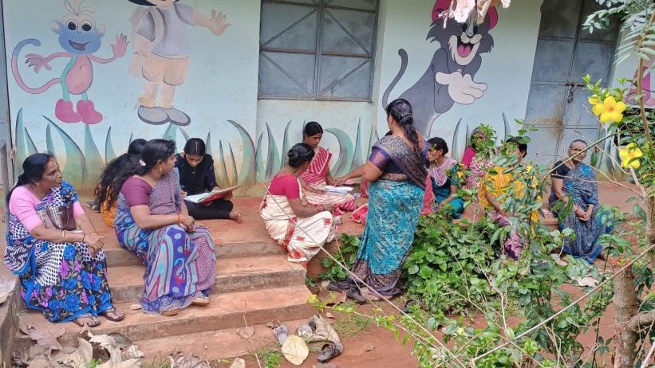

(Yamuna GV SHG – periodical meeting)

* + All the SHGs in GVST were trained with basic financial management which is applicable to the groups and they are maintaining proper accounting and book-keeping which are periodically audited during the year. Each Group maintains records such as General Ledger, Cash Book, Minutes Book, Receipts and Vouchers, Saving Ledger and Members Passbook and Ledger for members. In addition, periodical SHG meetings were conducted in the presence of GVST’s Field Animators.
  + Our organization plays a pivotal role in empowering communities by facilitating credit assistance through bank linkages and microfinance initiatives. These financial support programs are designed to promote sustainable livelihood activities, enabling individuals, particularly from marginalized backgrounds, to start or expand small businesses and income-generating enterprises. Through strategic partnerships with banks and financial institutions, we helped beneficiaries access loans and credit facilities that would otherwise be out of reach. Our microfinance efforts focus on fostering self-reliance by providing manageable loans with fair terms, supporting ventures like agriculture, animal husbandry, small-scale manufacturing, and trade. These initiatives not only improve economic stability but also uplift entire communities by reducing poverty and encouraging entrepreneurship.

1. **Capacity Building and Leadership Training**
   * The organization conducts training on leadership and communication skills, equipping women with the skills to lead and advocate for themselves and their communities.
2. **Financial Assistance and Bank/Credit Linkages**
   * GVST facilitates credit assistance from NABARD-NABFINS and providing training to help women effectively manage finances, saving and investing for the future.
3. **Entrepreneur Development Programs (EDP)**
   * The Entrepreneur Development Programs offer support and resources for women to develop small businesses, such as handicrafts, food stalls, and grocery shops, which contribute to their economic independence and community growth.
4. **Income Generating Activities for Widows**
   * Specialized income-generating initiatives targeting widows, including livestock rearing, handicraft creation, and other small business ventures. This support empowers widows to build sustainable livelihoods and gain financial security.
5. **Social Security Schemes**
   * GVST provides social security schemes with significant financial support for disadvantaged SHG members, offering a safety net that improves resilience in times of need.
6. **Health Awareness and Medical Camps**
   * The organization has raised awareness around health and hygiene and organized medical camps, ensuring women have access to basic healthcare and knowledge to maintain their health and that of their families.
7. **Educational Support Programs**
   * GVST has offered educational support to women and children, facilitating access to education as a crucial step toward economic and social upliftment.

**Impact and Outcomes**

The programs initiated by GVST have resulted in empowering women to make informed decisions, effectively manage finances, and improve overall well-being. By promoting financial literacy, health awareness, legal knowledge, and leadership, GVST has fostered a sense of confidence and self-reliance among women, encouraging them to take on leadership roles within their communities. Many beneficiaries of these programs have become agents of change, inspiring others and contributing to collective growth. GVST’s holistic approach to women’s empowerment, from economic support to social security and education, has established a strong, supportive environment for sustainable development. Through these initiatives, GVST is committed to fostering a lasting impact, transforming the lives of women and empowering communities to thrive.

SHG Members of GVST are very active and they are capacitated to generate income through self-employment and entrepreneurship programs supported by the organization and govt. agencies.

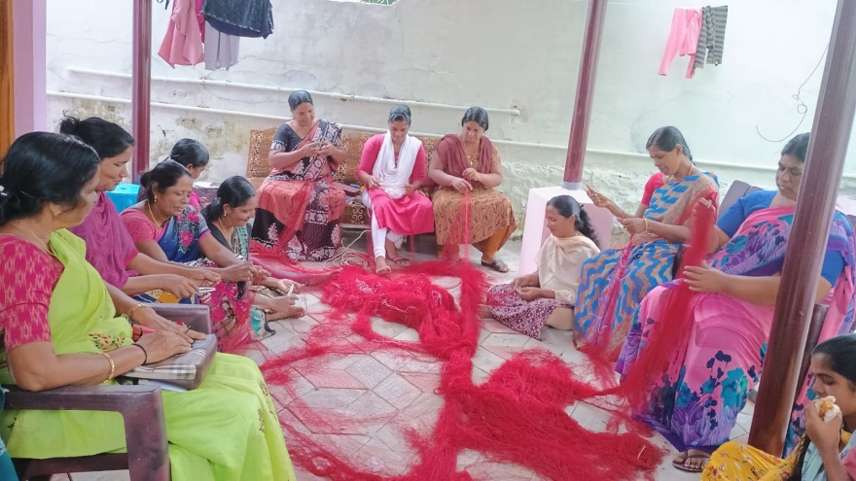

**(Sagaya Matha GV SHG)**

To fulfill the credit needs of the SHG members with easy accessibility we have entered into an agreement with NABFINS, a subsidiary of NABARD as Business Correspondent. As the credit is given at a reasonable interest, SHG members can invest the money in income generating activities which helps to improve their standard of living. By improving the rural sector, Good Vision Seva Trust is paving a path to sustainable development. Many of our SHGs have successfully ventured into a variety of micro-enterprises, setting the foundation for sustainable livelihoods.

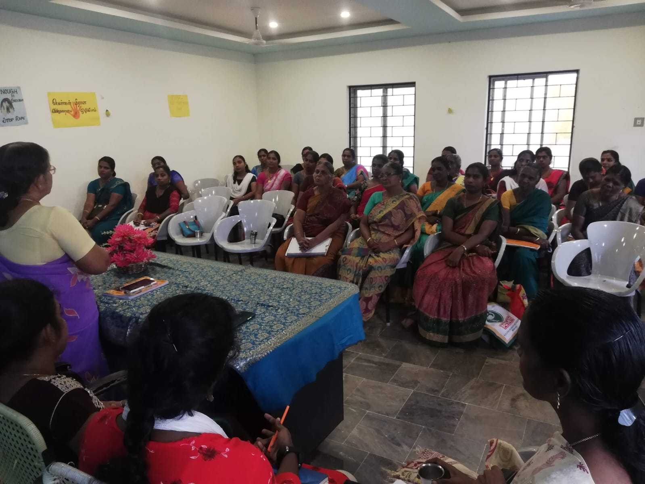

**(SHG Representatives’ meeting)**

We have organized Animators and Representative training (A&R Training) to the SHG Members to enhance their representative and leadership skills. Around 45 members took part in the training.

**Mega Free Career Guidance Program:**

GVST recently organized a comprehensive Mega Free Career Guidance Program on 8th April 2023 aimed at empowering thousands of +2 students with valuable knowledge and resources to navigate their educational and career paths effectively. Understanding the critical juncture that students face at this stage, the program was designed to equip them with up-to-date information about a wide array of courses and career options.

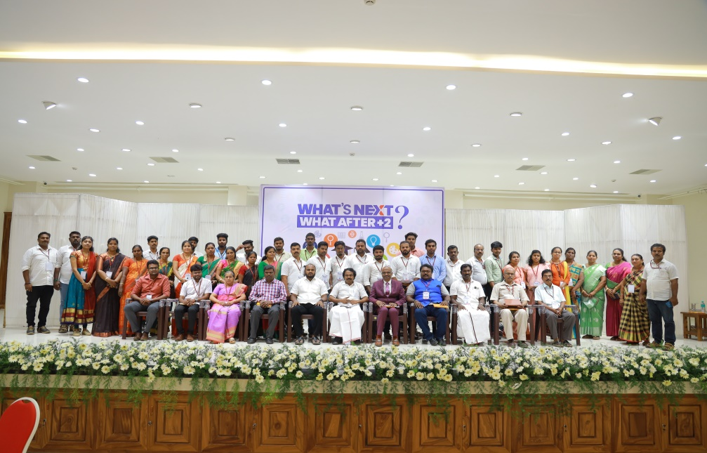

**Objectives of the Program:**

1. **Course and Subject Selection**: The program provided in-depth insights into various academic disciplines, assisting students in making informed decisions about which subjects align with their aspirations and interests.

2. **Institution Selection:** Participants received guidance on selecting reputable institutions that offer their desired courses, ensuring they have access to quality education.

3. **Scholarship Information**: The program highlighted various scholarship opportunities, both national and international, enabling students to explore financial assistance options that can alleviate the burden of educational expenses.

**4. Career Opportunities:** In addition to academic guidance, the program showcased a diverse range of career paths available to students, including emerging sectors and job markets, thereby broadening their perspectives on future opportunities.

**5. National and International Exposure:** Representatives from various institutions and organizations were invited to discuss internships, exchange programs, and other enriching experiences that can enhance students' education and employability on a global scale.

**Program Highlights:**

**Expert Speakers:** The event featured expert speakers from various fields, including education consultants, career counselors, and representatives from top institutions, who shared their insights and experiences with the students.

**Interactive Sessions**: Engaging workshops and Q&A sessions allowed students to interact directly with professionals and gain personalized advice tailored to their individual goals.

**Resource Materials**: Participants received informative brochures and handouts containing key details about courses, institutions, and scholarships, which they could reference as they plan their futures.

**Networking Opportunities**: The program fostered a community atmosphere, allowing students to connect with peers, share experiences, and build a network that can support them in their educational journeys.

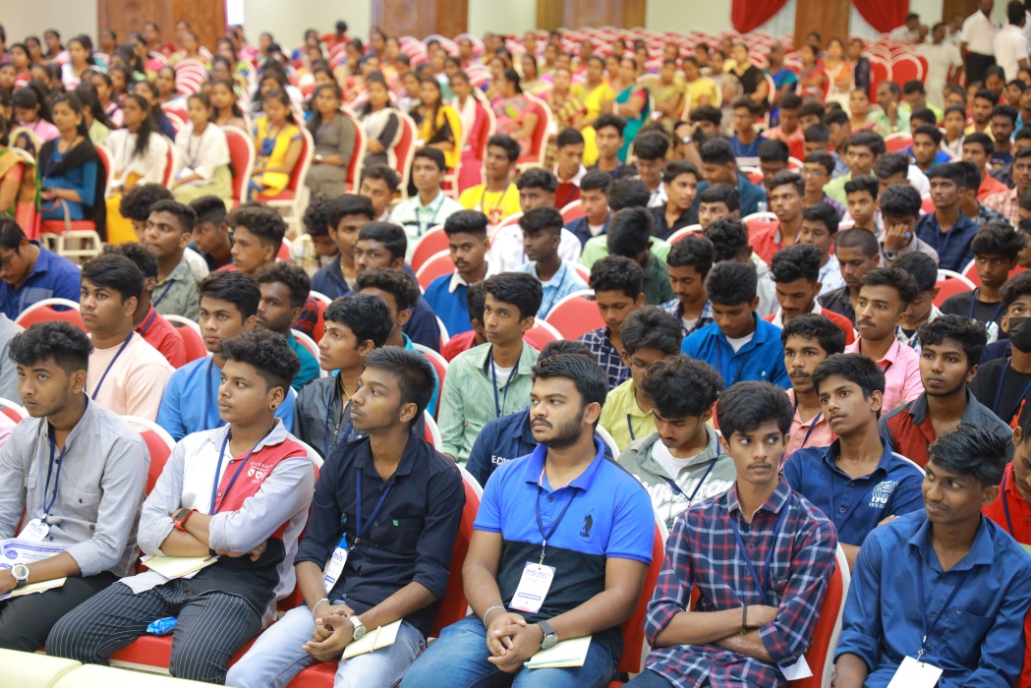

**Impact of the Program**: The Mega Free Career Guidance Program has significantly empowered thousands of +2 students by demystifying the process of career planning and giving them the tools they need to make sound decisions about their futures. By bridging the gap between education and employment, GVST has taken concrete steps towards enhancing the prospects of the youth, encouraging them to aspire for excellence and pursue their dreams with confidence. This initiative reflects GVST's commitment to nurturing talent and fostering a well-informed generation capable of contributing positively to society.

**(E) Health Care**

Our organization has undertaken a wide range of health and wellness initiatives to promote well-being among the rural and urban community such as implementing sanitation programs, along with the health education and awareness programs to improve hygiene as well as prevent illness. We actively promote alternate healthcare practices and indigenous medicines, organizing general health camps and specialized eye camps to ensure accessible medical care. Our Homeopathy Health Sub-Centers offer affordable treatment, while we also provide essential vitamin supplies to address nutritional needs. Through our palliative care services and patient Counselling centers, we offer comfort and support to those in critical need. Additionally, we run prevention camps for diseases like Dengue and Chikungunya and provide psycho-social care support to address mental well-being, ensuring holistic health care for the community.

Through our organization, we extend small yet meaningful support to patients living in extreme poverty, helping them access hospitals and purchase essential medicines. This assistance covers a portion of their medical expenses, offering relief to families struggling to afford care. Our focus is primarily on families with bedridden patients, ensuring they receive the treatment they need during difficult times. This initiative reflects our commitment to alleviating some of the burdens faced by the most vulnerable in our community.

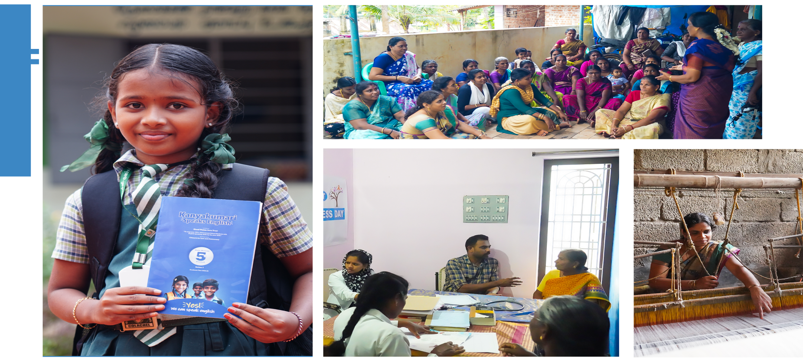

**(Homeopathy health professionals reviewing patients)**

**Homeopathy health sub-centers:**

For the past 12 years, we have been running two Homeopathy health sub-centres in partnership with Saratha Krishna Homeopathy Medical College, making quality healthcare accessible to those in need. Guided by eminent doctors, these centers offer medical check-ups and treatments for a nominal fee of just twenty rupees per patient, per week.

Every week, over 100 patients—many from economically disadvantaged backgrounds—receive care and medication. Our Self-Help Groups (SHGs) actively spread awareness about these services, referring patients, especially those who are poor, marginalized, or overlooked by conventional healthcare systems.

The community has embraced these centers with gratitude, as patients not only receive compassionate care but also benefit from medication without the burden of side effects. Many individuals have experienced significant recovery, finding renewed hope and well-being through this initiative.

|  |  |  |
| --- | --- | --- |
| **At Karungal** | **At Amsi (Thengapattanam)** | **Eye Camps** |
| Nearly 2,650 patients were benefitted through this sub-centre. | Around 750 patients benefitted through this sub-centre. | More than 150 people were benefitted through 3 Eye camps on different occasions. |

**(F) Environment**

Our organization is deeply committed to environmental conservation, actively addressing critical ecological challenges through a variety of targeted actions. We understand that the protection of our planet's natural resources and biodiversity is essential for the health of ecosystems and for the well-being of future generations. To this end, we focus our efforts on mitigating several pressing environmental issues, including deforestation, pollution, and climate change.

**Addressing Key Environmental Challenges**

**Deforestation:**

Deforestation poses a significant threat to biodiversity and contributes to climate change. We engage in initiatives aimed at reforesting areas that have been stripped of their trees. For example, our organization has undertaken tree-planting campaigns in the Kanyakumari district, which not only enhance local biodiversity but also improve air quality and combat soil erosion. These initiatives help restore vital habitats for wildlife and contribute to carbon sequestration, mitigating climate change effects.

**Pollution:**

Pollution—whether in the form of plastic waste, chemical runoff, or air pollutants—impacts both human health and wildlife. Our organization has launched awareness programs that educate community members about the importance of reducing waste, recycling, and adopting cleaner technologies. By fostering a culture of environmental responsibility, we empower individuals to take action against pollution at the local level and reduce their ecological footprint.

**Climate Change:**

Climate change represents one of the most significant obstacles to sustainable development. Recognizing its far-reaching effects, we advocate for practices that enhance resilience, such as sustainable agriculture, water conservation, and the use of renewable energy sources. Our programs include training local farmers in climate-smart agricultural practices, which improve crop yields while reducing environmental impact.

**Promoting Community-Based Initiatives:**

A cornerstone of our approach is the promotion of community-based initiatives that empower local populations to take ownership of conservation activities. We firmly believe that the best solutions to environmental challenges often come from those who understand their local context.

**Empowerment and Education:** Through training, workshops and participatory planning sessions, we educate community members about ecological issues and the importance of conserving natural resources. This knowledge empowers them to make informed decisions about their environment.

**Sustainable Practices:** We work alongside local leaders and groups to implement and promote sustainable practices, such as organic farming, rainwater harvesting, and community forestry. These initiatives not only protect the environment but also provide economic benefits, enhancing the quality of life within the community.

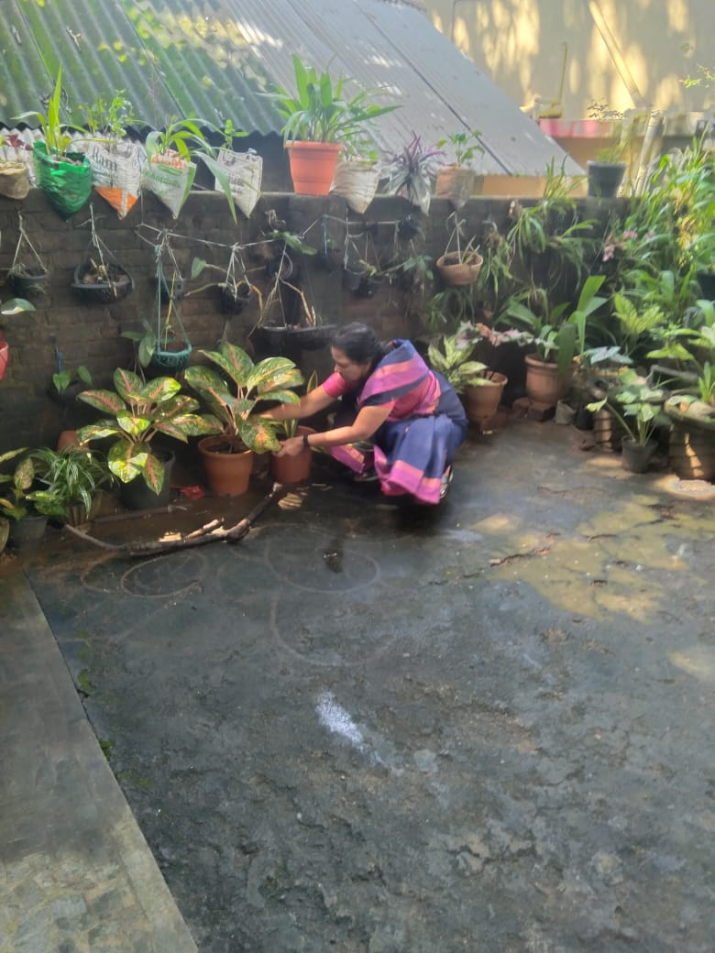

(SHG women engaged in kitchen garden activity)

**Local Stewardship:** By fostering a sense of ownership and responsibility for local ecosystems, we encourage communities to engage in stewardship activities. This includes organizing clean-up drives, tree planting events, and conservation projects that directly involve community members.

**Building a Greener, More Resilient Future:**

Through our collective efforts, we aim to create a sustainable future where environmental protection and community wellbeing go hand-in-hand. Our commitment to blending environmental awareness with grassroots participation ensures that we address current ecological challenges while laying the groundwork for long-term resilience.

By mobilizing communities and encouraging active participation, we not only protect the environment but also enhance the livelihoods of local populations. This holistic approach reflects our vision of a greener, more resilient world where ecological integrity and human prosperity coexist.

**In a nutshell:** Our organization’s initiatives in the Kanyakumari district, which include tree planting efforts and awareness programs, are part of a broader commitment to environmental conservation. By addressing key environmental challenges through community-based strategies, we aim to empower individuals and groups towards building a sustainable future for generations to come.

**(6) Financial Overview**

**Major Donors:** We extend our heartfelt gratitude to the following major donors for their generous contributions:

1. Indian Oil Corporation Limited

2. Noorul Islam Center for Higher Education University, Kumaracoil

3. Rajas Dental College and Hospital

4. Britto Timbers

5. Lezdo TechMech Pvt Ltd

6. Nila Apps PVT Ltd

**Funding Allocation:** The funding received has been allocated across key focus areas such as administration, projects like English **Vocabulary Drill, Flood Relief in Thoothukudi and Tirunelveli district, Homeopathy Medical Centre,** Eye Camps, etc.

Our financial statements for the year underwent an independent audit by Deepa Victor and Associates. The audit was conducted in strict accordance with financial reporting standards, ensuring compliance and accuracy. The auditors provided a clean audit opinion, confirming the transparency and reliability of our financial records. This reinforces our commitment to maintaining integrity and accountability in all financial dealings, allowing stakeholders to have confidence in our operations.

This financial overview reflects our dedication to effectively utilize resources for the greater benefit of the communities we serve, highlighting the importance of transparent accounting and robust governance practices.

**(7) Acknowledgements**

We express our heartfelt gratitude to all those who have made significant contributions to our multifaceted initiatives aimed at fostering sustainable growth and development across various focus areas.

First and foremost, we extend our sincere thanks to our generous **donors.** Your unwavering support has been vital in funding our education initiatives, healthcare programs, and environmental conservation efforts, empowerment of women, livelihood support activities, and disaster management strategies. Your belief in our mission allows us to create lasting change in the communities we serve.

We are immensely grateful to our **partners** who collaborate with us across these diverse focus areas. Your expertise and resources have enriched our programs and amplified our impact, enabling us to address complex challenges ranging from educational disparities to environmental sustainability and community resilience.

A special recognition goes to our **dedicated volunteers**, whose selfless service and commitment to our initiatives in education, healthcare, and empowering women are truly inspiring. Your hard work in organizing awareness campaigns, providing support to those in need, and facilitating skill development programs is invaluable to the success of our mission.

We also thank our committed **staff members**, whose professionalism and passion drive our efforts in every focus area. From coordinating healthcare services to implementing livelihood support programs, your dedication to serving our communities is the foundation of our achievements.

Furthermore, we express our appreciation to **the local communities and beneficiaries** we serve. Your active engagement and participation in our programs—whether in educational workshops, healthcare services, environmental initiatives, or disaster preparedness efforts—are essential to their success. Your resilience and commitment to improvement motivate us every day.

Finally, we wish to acknowledge the support of **local authorities and organizations** that provide guidance and collaboration in our initiatives. Your partnership has been instrumental in fostering a conducive environment for our work, particularly in disaster management and community development.

Together, with your collective support, we are working towards a brighter future—one characterized by enhanced education, improved healthcare, empowered women, sustainable livelihoods, and resilient communities. Thank you for your unwavering commitment and partnership in this critical journey.

**(8) Future Plans: Goals and Upcoming Projects**

GVST remains wholeheartedly committed to empowering communities through financial inclusion and sustainable livelihood opportunities. By facilitating credit assistance through bank linkages and microfinance, we have enabled individuals, particularly from marginalized backgrounds, to embark on income-generating activities that foster self-reliance and promote economic stability. These efforts have transformed lives, encouraging entrepreneurship and significantly reducing poverty at the grassroots level.

As we look to the future, we aim to further strengthen our financial support programs, ensuring that even more individuals gain access to the resources necessary to build a secure and prosperous future. Our work stands as a testament to the belief that economic empowerment is the cornerstone of sustainable development. We are eager to scale new heights with the ongoing support of our partners, beneficiaries, and stakeholders.

**Our future plans include the following key initiatives:**

**Formation of more new SHGs:** At GVST, we recognize the transformative power of SHGs in fostering community strength and empowering individuals, particularly women. Our commitment to forming more new SHGs is a strategic component of our efforts to promote financial inclusion, enhance livelihoods, and encourage sustainable development withi marginalized communities.

**Expansion of the "English for Economic Opportunities" Project**: We will work to broaden the reach of this initiative across Tamil Nadu, enhancing language skills that open pathways to better job prospects and economic advancement.

**Increased Healthcare Services**: We will continue to provide essential healthcare services to underserved communities, addressing health disparities and improving overall well-being.

**Skilling Programs for Youth and Women:** Our focus will be on launching skilling programs, including career guidance that empower young people and women, equipping them with the necessary tools and training to thrive in today's economy.

**Promotion of Gender Sensitization and Eradication of Violence against Women**: We are dedicated to fostering awareness and advocating for gender parity while actively working to combat violence against women through community engagement and education.

**Sanitation Initiatives**: We will initiate sanitation programs, including projects like pipe composting, leach pits, and the "Litter-Free Kanyakumari" campaign. These efforts aim to combat plastic pollution and promote better waste management practices within communities.

Through these initiatives, GVST aspires to continue making a meaningful impact, driving progress in economic empowerment, health, education, and environmental sustainability. We believe that by investing in our communities, we can create a brighter, more resilient future for all.

**(9) Contact Information**

**Good Vision Seva Trust**

Registered Office: 5/235 B, Paloor, Karungal, Kanyakumari district - 629157.

Corporate Office: 150, Agurchand Mansion, Anna Salai, Mount Road, Chennai - 600002.

**Phone:** 9442391166; 04651-269166; 9790743673

**Email:** [goodvisionadmin@gmail.com](mailto:goodvisionadmin@gmail.com);

**Website:** <https://goodvisionsevatrust.org>